* CB FSD - Integration and Deployment

Day 7 : 23 July 2024

Jenkin pipe line : Jenkin pipe line is a collection of event or jobs or task which are interlinked with one another in a sequence to big task is known as Jenkin pipe line jobs.

Jenkin pipe line we use script file which contains set of commands to execute.

That script file we can write locally or we can take that script file from Git hub account with default name for the script file is Jenkinsfile.

Script file to run simple java program

pipeline {

agent any

stages {

stage('Check Software Setup') {

steps {

echo 'Checking Java Version'

sh 'java -version'

}

}

stage('Pull github project') {

steps {

echo 'Pull Github javaproject'

git 'https://github.com/Kaleakash/jenkinjava.git'

sh 'ls'

}

}

stage('Compile the Program') {

steps {

echo 'Compile the program'

sh 'javac Demo.java'

}

}

stage('Run the Program') {

steps {

echo 'Run the program'

sh 'java Demo'

}

}

}

}

Creating external script file part of SCM ie github account.

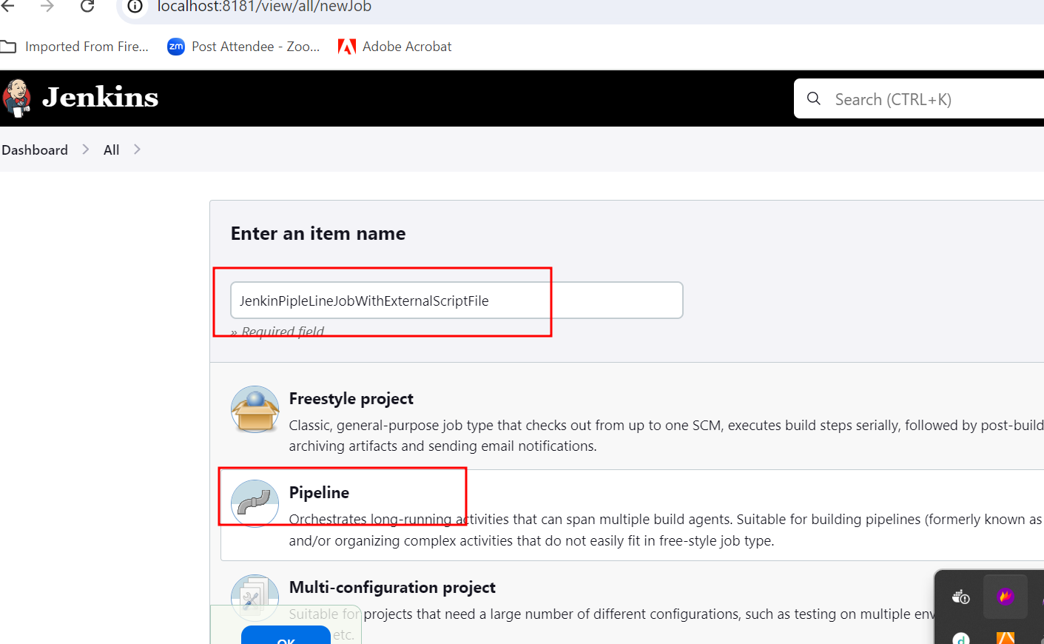

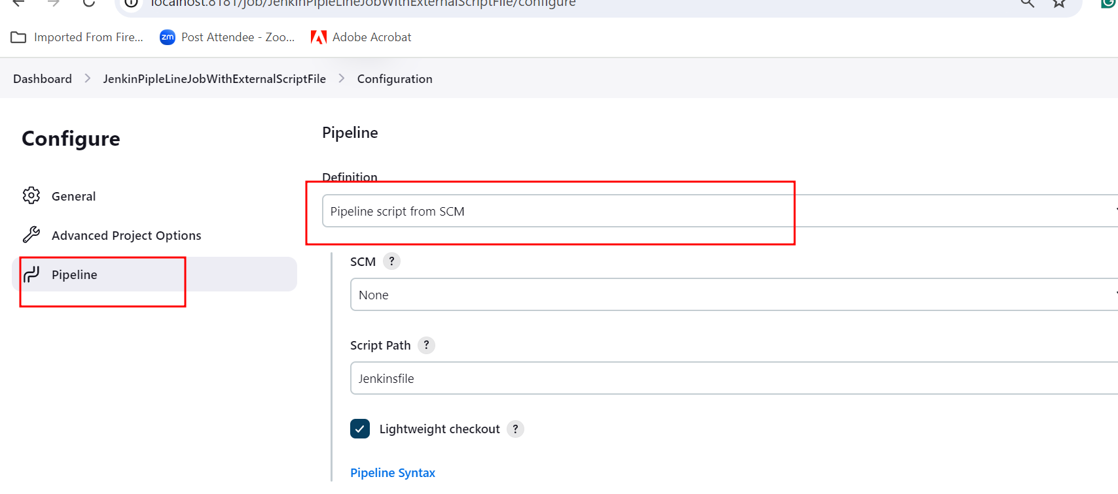

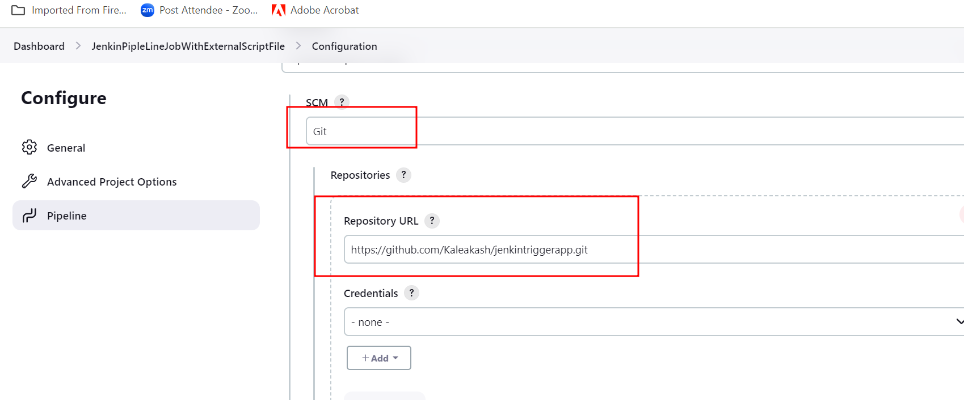

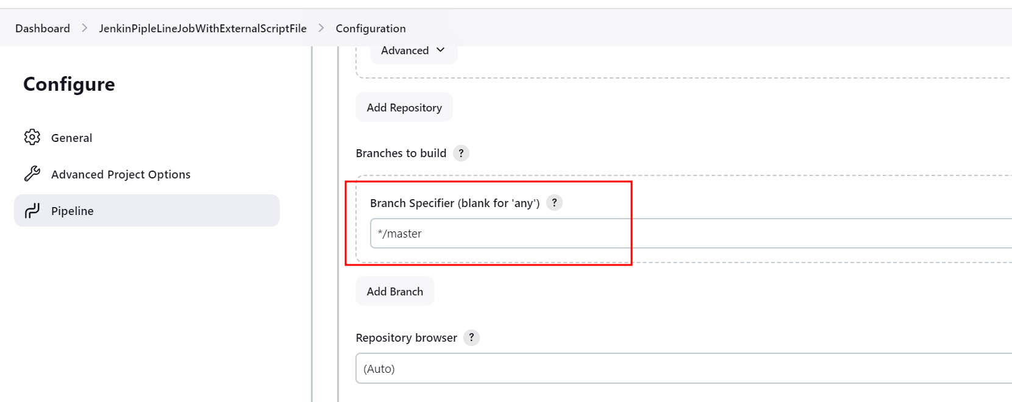

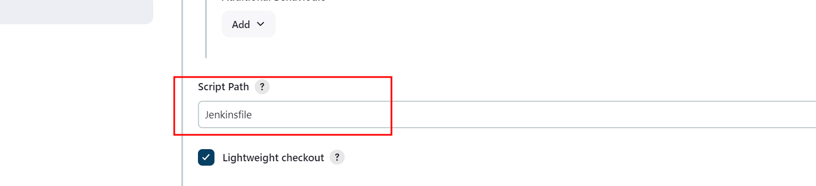

The apply and save

Then build the project

